**SCHEMAS**

**SCHEMAS** : DATABASE OBJECTS USED TO **GROUP TABLES**.

LIKE FOLDERS IN A DRIVE.

**PURPOSE** : USED FOR EASY DATA ACCESS AND **EASY** SECURITY MANAGEMENT.

DEFAULT SCHEMA IS "**DBO**". MEANS, DATABASE OWNER.

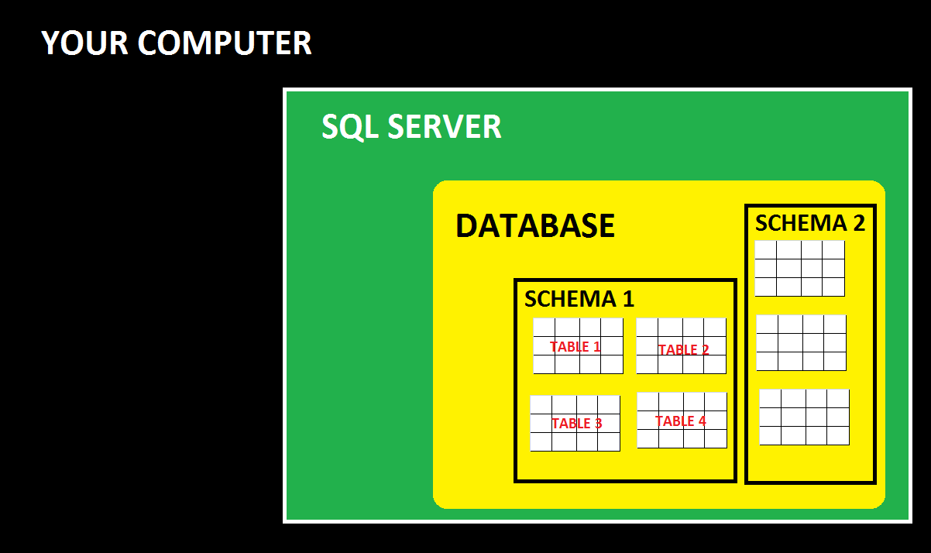

A DATABASE CAN HAVE UNLIMITTED NUMBER OF **SCHEMAS**.

EACH SCHEMA CAN HAVE UNLIMITTED NUMBER OF **TABLES**.